AHMAD MALIK FAJAR

SOAL 6.1

1. Query : [CREATE](http://localhost/phpmyadmin/url.php?url=https://dev.mysql.com/doc/refman/8.0/en/create-procedure.html) [PROCEDURE](http://localhost/phpmyadmin/url.php?url=https://dev.mysql.com/doc/refman/8.0/en/create-procedure.html) pro_naikan_harga( [IN](http://localhost/phpmyadmin/url.php?url=https://dev.mysql.com/doc/refman/8.0/en/comparison-operators.html%23function_in) jenis_produk_id INT, [IN](http://localhost/phpmyadmin/url.php?url=https://dev.mysql.com/doc/refman/8.0/en/comparison-operators.html%23function_in) persentase_kenaikan DECIMAL(5,2) ) BEGIN [UPDATE](http://localhost/phpmyadmin/url.php?url=https://dev.mysql.com/doc/refman/8.0/en/update.html) produk [SET](http://localhost/phpmyadmin/url.php?url=https://dev.mysql.com/doc/refman/8.0/en/set.html) harga_jual = harga_jual + (harga_jual * persentase_kenaikan / 100) WHERE jenis_produk_id = jenis_produk_id; END;

Hasil :

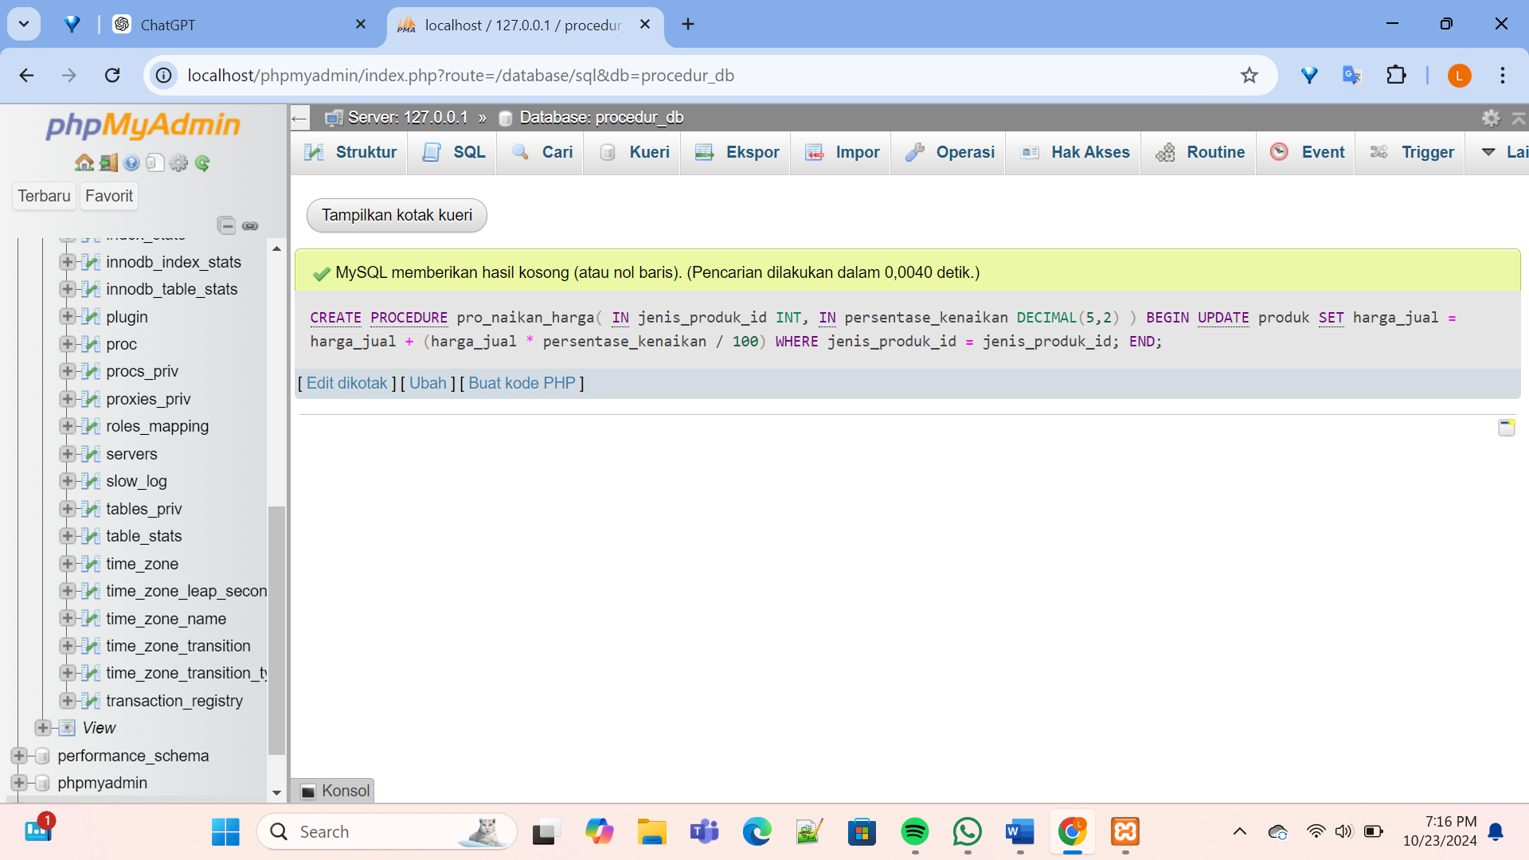

1. Query : [CREATE](http://localhost/phpmyadmin/url.php?url=https://dev.mysql.com/doc/refman/8.0/en/create-function.html) [FUNCTION](http://localhost/phpmyadmin/url.php?url=https://dev.mysql.com/doc/refman/8.0/en/create-function.html) umur(tgl_lahir DATE) RETURNS INT DETERMINISTIC BEGIN [DECLARE](http://localhost/phpmyadmin/url.php?url=https://dev.mysql.com/doc/refman/8.0/en/declare.html%23declare) umur INT; [SET](http://localhost/phpmyadmin/url.php?url=https://dev.mysql.com/doc/refman/8.0/en/set.html) umur = YEAR(CURDATE()) - YEAR(tgl_lahir); -- Jika bulan dan hari tgl_lahir lebih besar dari tanggal hari ini, kurangi 1 dari umur [IF](http://localhost/phpmyadmin/url.php?url=https://dev.mysql.com/doc/refman/8.0/en/control-flow-functions.html%23function_if) (MONTH(CURDATE()) < MONTH(tgl_lahir)) [OR](http://localhost/phpmyadmin/url.php?url=https://dev.mysql.com/doc/refman/8.0/en/logical-operators.html%23operator_or) (MONTH(CURDATE()) = MONTH(tgl_lahir) [AND](http://localhost/phpmyadmin/url.php?url=https://dev.mysql.com/doc/refman/8.0/en/logical-operators.html%23operator_and) DAY(CURDATE()) < DAY(tgl_lahir)) THEN [SET](http://localhost/phpmyadmin/url.php?url=https://dev.mysql.com/doc/refman/8.0/en/set.html) umur = umur - 1; END [IF](http://localhost/phpmyadmin/url.php?url=https://dev.mysql.com/doc/refman/8.0/en/control-flow-functions.html%23function_if); RETURN umur; END;

Hasil :

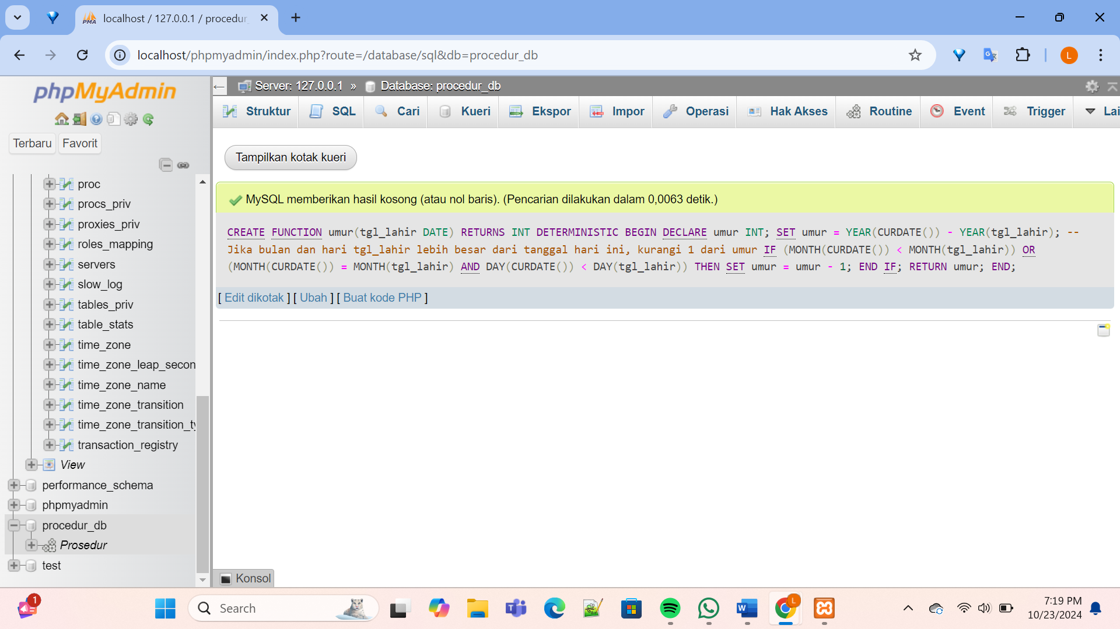

1. Query : [CREATE](http://localhost/phpmyadmin/url.php?url=https://dev.mysql.com/doc/refman/8.0/en/create-function.html) [FUNCTION](http://localhost/phpmyadmin/url.php?url=https://dev.mysql.com/doc/refman/8.0/en/create-function.html) kategori_harga(harga DOUBLE) RETURNS VARCHAR(20) DETERMINISTIC BEGIN [DECLARE](http://localhost/phpmyadmin/url.php?url=https://dev.mysql.com/doc/refman/8.0/en/declare.html%23declare) kategori VARCHAR(20); [IF](http://localhost/phpmyadmin/url.php?url=https://dev.mysql.com/doc/refman/8.0/en/control-flow-functions.html%23function_if) harga BETWEEN 0 [AND](http://localhost/phpmyadmin/url.php?url=https://dev.mysql.com/doc/refman/8.0/en/logical-operators.html%23operator_and) 500000 THEN [SET](http://localhost/phpmyadmin/url.php?url=https://dev.mysql.com/doc/refman/8.0/en/set.html) kategori = 'murah'; ELSEIF harga BETWEEN 500001 [AND](http://localhost/phpmyadmin/url.php?url=https://dev.mysql.com/doc/refman/8.0/en/logical-operators.html%23operator_and) 3000000 THEN [SET](http://localhost/phpmyadmin/url.php?url=https://dev.mysql.com/doc/refman/8.0/en/set.html) kategori = 'sedang'; ELSEIF harga BETWEEN 3000001 [AND](http://localhost/phpmyadmin/url.php?url=https://dev.mysql.com/doc/refman/8.0/en/logical-operators.html%23operator_and) 10000000 THEN [SET](http://localhost/phpmyadmin/url.php?url=https://dev.mysql.com/doc/refman/8.0/en/set.html) kategori = 'mahal'; ELSEIF harga > 10000000 THEN [SET](http://localhost/phpmyadmin/url.php?url=https://dev.mysql.com/doc/refman/8.0/en/set.html) kategori = 'sangat mahal'; ELSE [SET](http://localhost/phpmyadmin/url.php?url=https://dev.mysql.com/doc/refman/8.0/en/set.html) kategori = 'tidak valid'; -- Jika harga kurang dari 0 atau tidak sesuai END [IF](http://localhost/phpmyadmin/url.php?url=https://dev.mysql.com/doc/refman/8.0/en/control-flow-functions.html%23function_if); RETURN kategori; END;

Hasil :

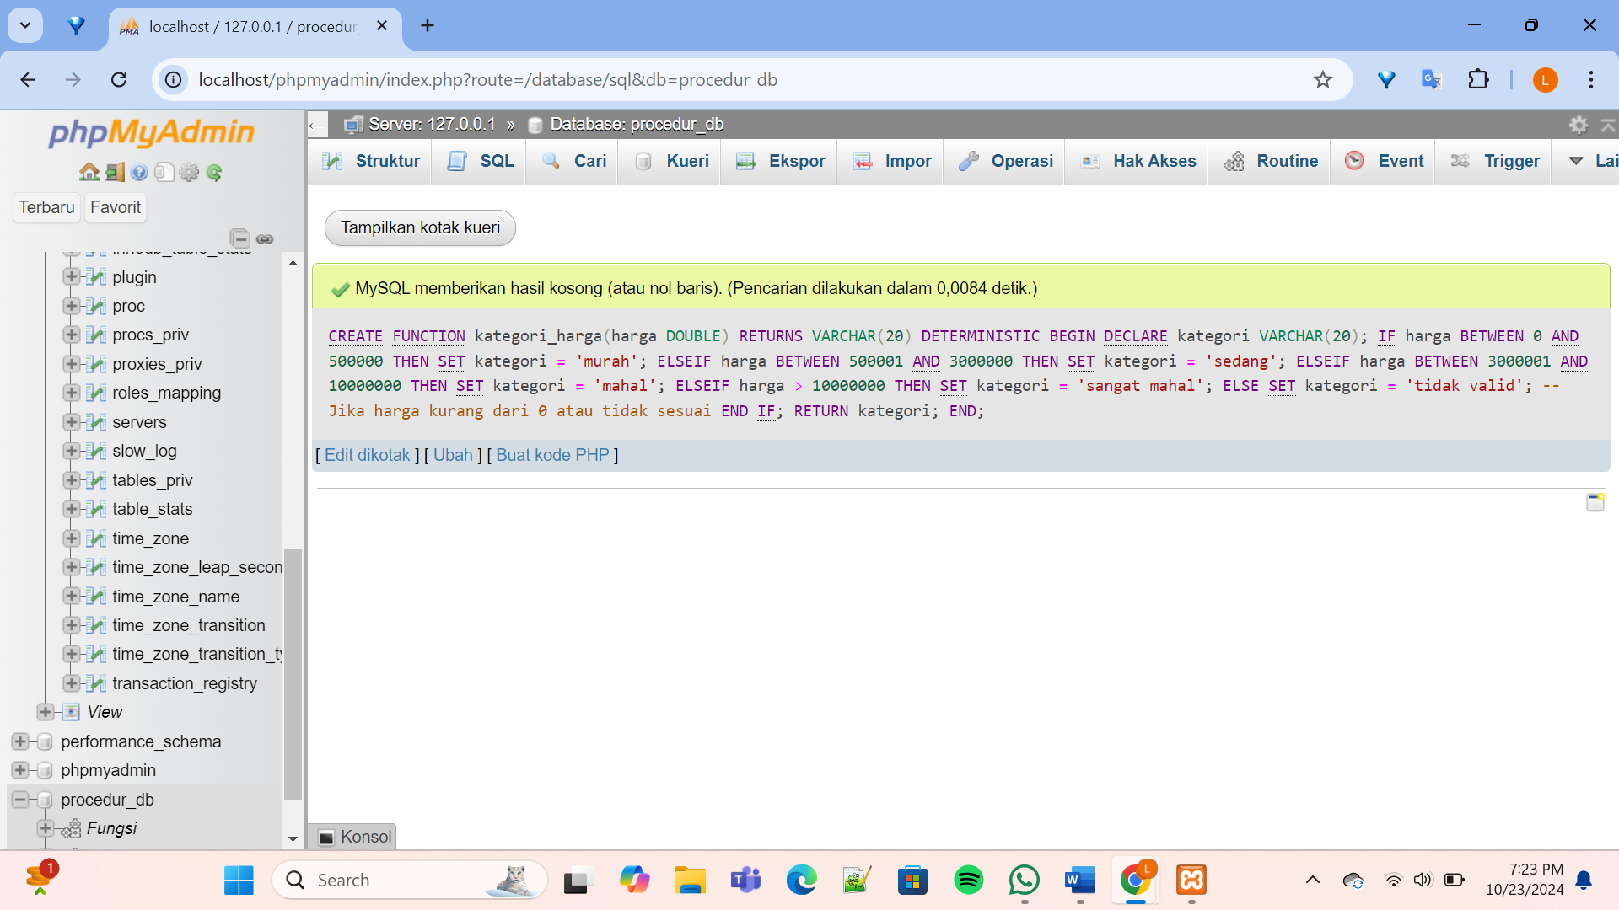

SOAL 6.2

1. Buatlah sebuah transaction dengan skenario-skenario statement sebagai berikut:
2. Mulai Transaction

* Query : START TRANSACTION;
* Hasil :

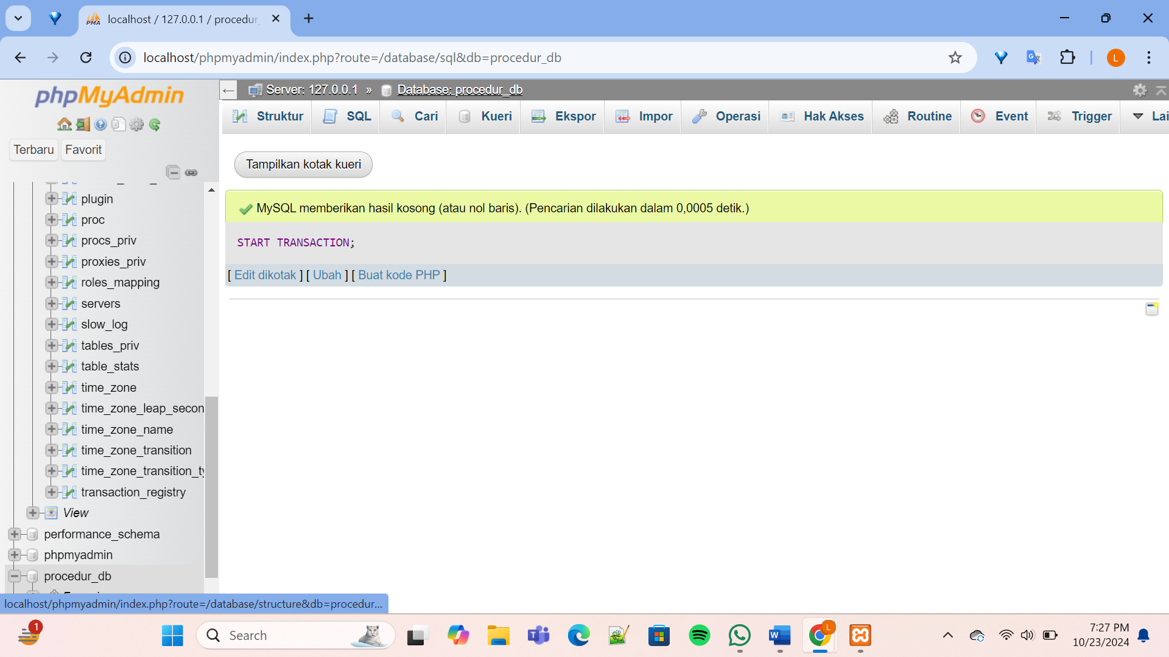

1. Insert data produk sebanyak 3 record

* Query : [CREATE](http://localhost/phpmyadmin/url.php?url=https://dev.mysql.com/doc/refman/8.0/en/create-table.html) [TABLE](http://localhost/phpmyadmin/url.php?url=https://dev.mysql.com/doc/refman/8.0/en/create-table.html) produk ( id_produk INT AUTO_INCREMENT PRIMARY KEY, nama_produk VARCHAR(100), harga_jual DECIMAL(10,2), stok INT, jenis_produk_id INT );
* Hasil :

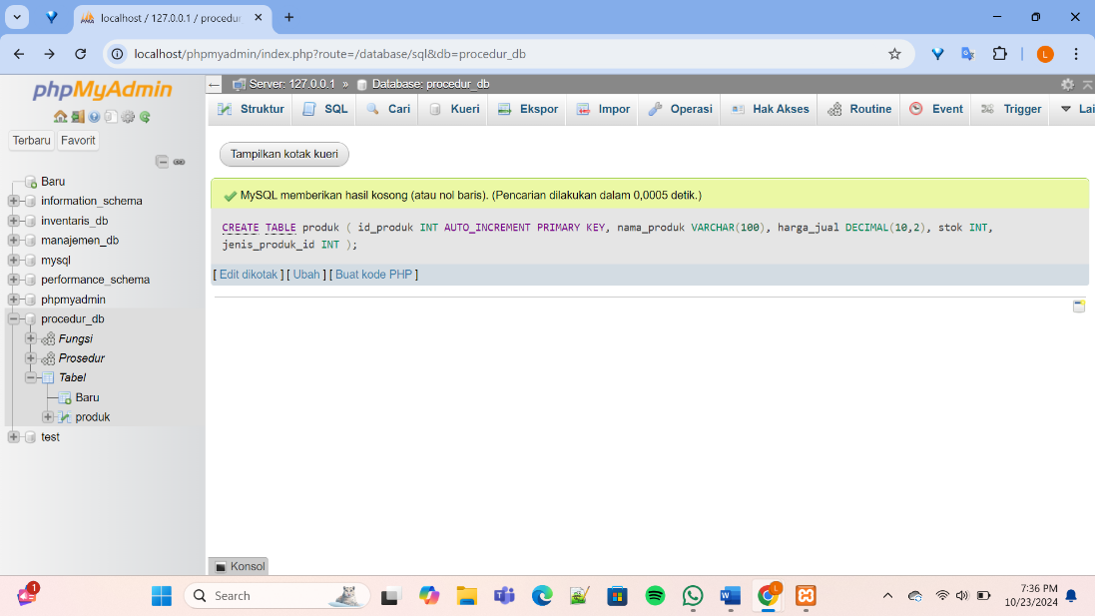

* Query :

[INSERT](http://localhost/phpmyadmin/url.php?url=https://dev.mysql.com/doc/refman/8.0/en/insert.html) INTO produk (nama_produk, harga_jual, stok, jenis_produk_id) [VALUES](http://localhost/phpmyadmin/url.php?url=https://dev.mysql.com/doc/refman/8.0/en/miscellaneous-functions.html%23function_values) ('Baju Batik', 100000, 20, 1), ('Celana Jeans', 200000, 70, 2), ('Kaos Polo', 150000, 50, 3);

* Hasil :

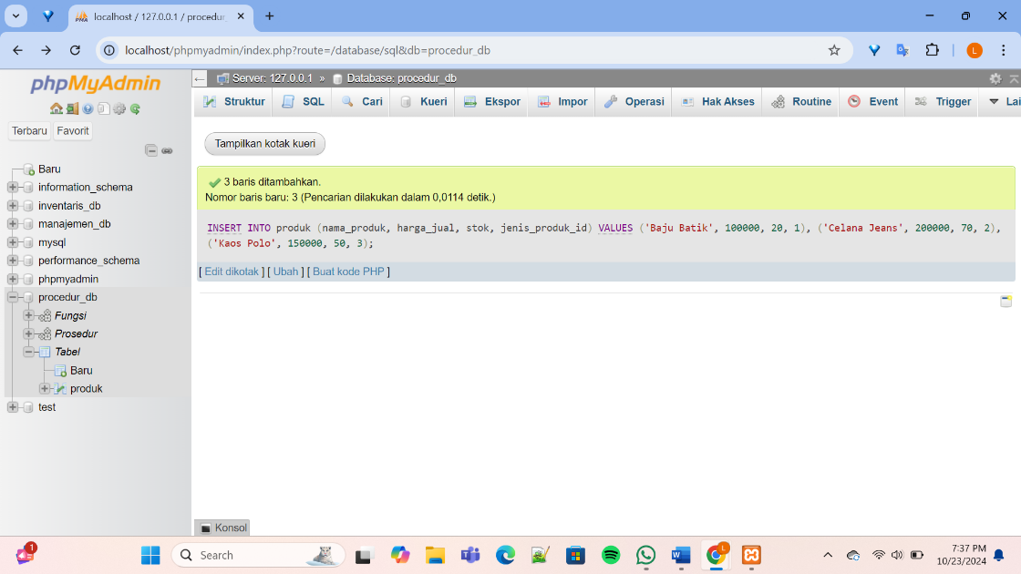

1. Update data stok salah satu produk

* Query :

[UPDATE](http://localhost/phpmyadmin/url.php?url=https://dev.mysql.com/doc/refman/8.0/en/update.html) produk [SET](http://localhost/phpmyadmin/url.php?url=https://dev.mysql.com/doc/refman/8.0/en/set.html) stok = stok + 20 WHERE nama_produk = 'Baju Batik';

* Hasil :

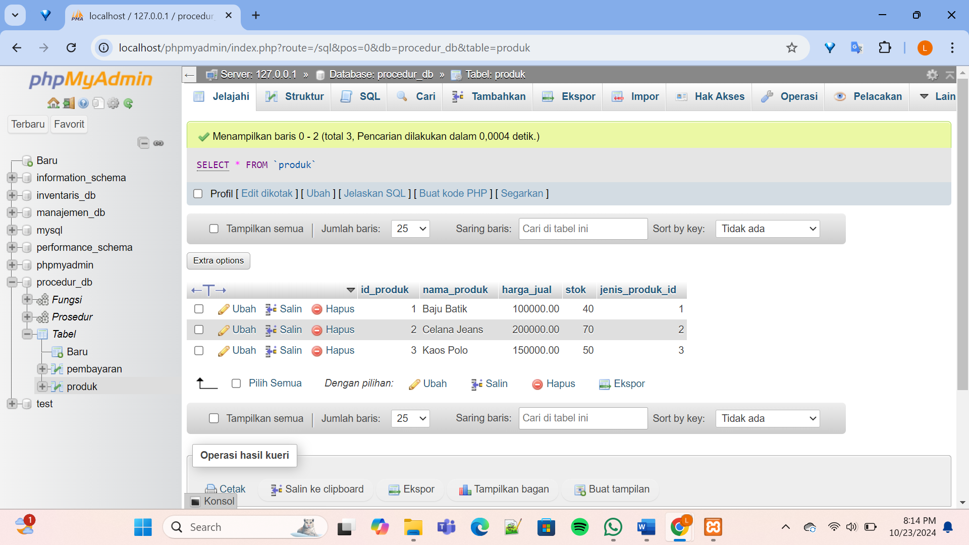

1. Buat savepoint

* Query : SAVEPOINT savepoint_before_delete;
* Hasil :

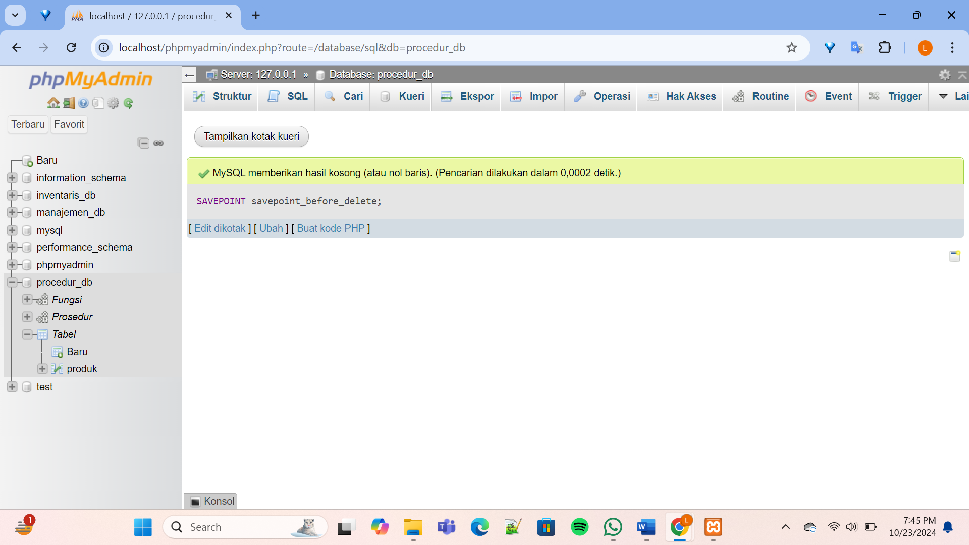

1. Hapus salah satu data pembayaran

(Membuat Tabel Pembayaran)

* Query : [CREATE](http://localhost/phpmyadmin/url.php?url=https://dev.mysql.com/doc/refman/8.0/en/create-table.html) [TABLE](http://localhost/phpmyadmin/url.php?url=https://dev.mysql.com/doc/refman/8.0/en/create-table.html) pembayaran ( id_pembayaran INT AUTO_INCREMENT PRIMARY KEY, jumlah DECIMAL(10,2), tanggal_pembayaran DATE, metode_pembayaran VARCHAR(50) );
* Hasil :

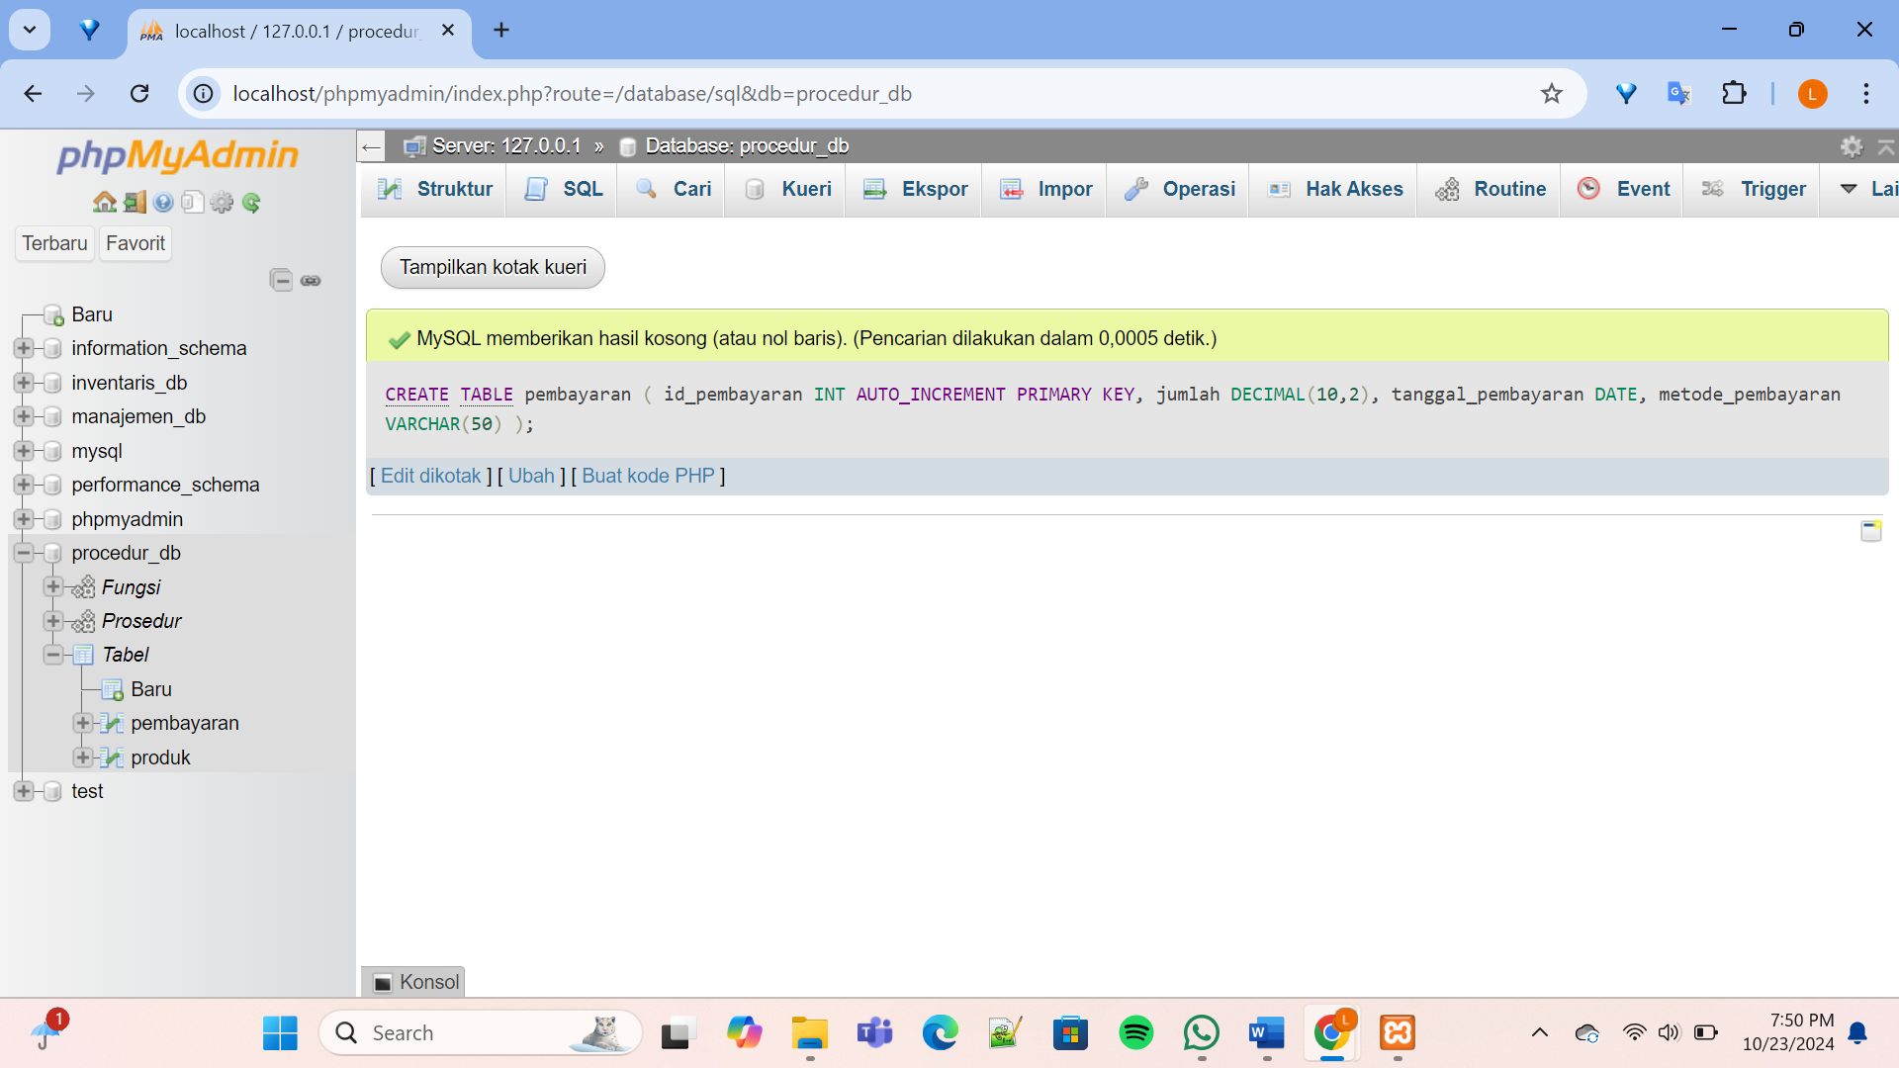

(Menambahkan data pembayaran)

* Query : [INSERT](http://localhost/phpmyadmin/url.php?url=https://dev.mysql.com/doc/refman/8.0/en/insert.html) INTO pembayaran (jumlah, tanggal_pembayaran, metode_pembayaran) [VALUES](http://localhost/phpmyadmin/url.php?url=https://dev.mysql.com/doc/refman/8.0/en/miscellaneous-functions.html%23function_values) (500000, '2024-10-01', 'Transfer Bank'), (300000, '2024-10-05', 'Ka Kredit'), (150000, '2024-10-10', 'Cash'), (250000, '2024-10-15', 'E-Wallet'), (450000, '2024-10-20', 'Transfer Bank');
* Hasil :

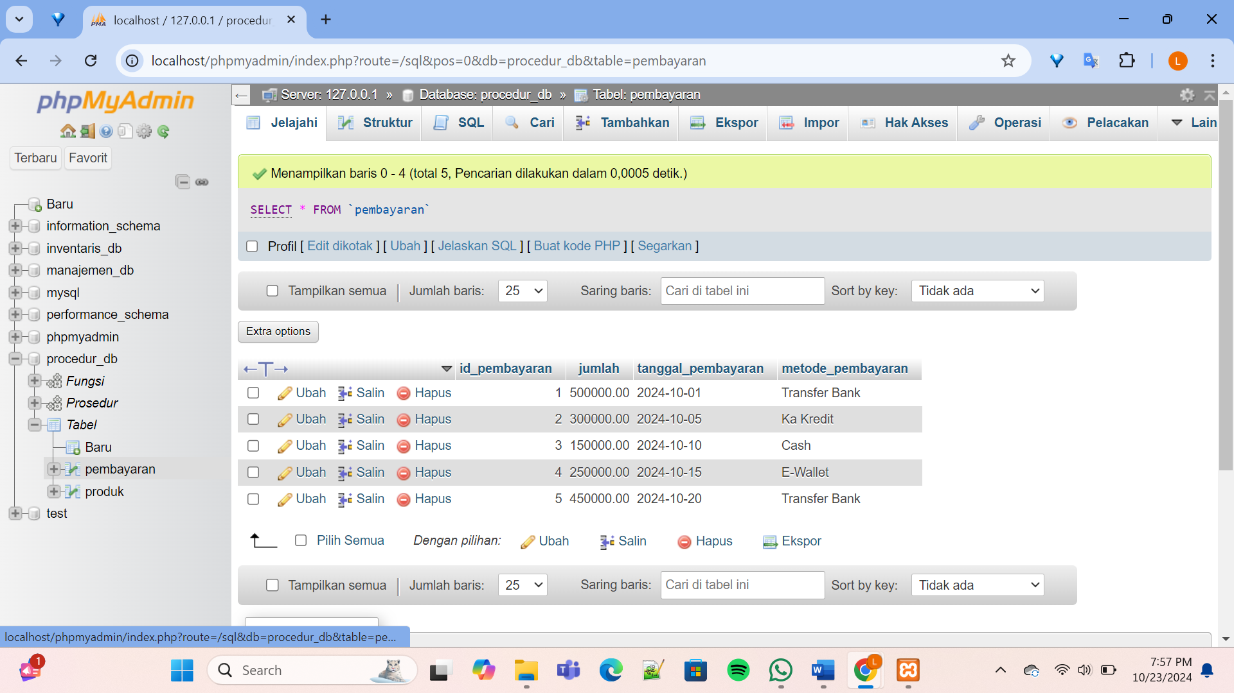

(Menghapus data pembayaran dengan Id pembayaran = 3)

* Query : [DELETE](http://localhost/phpmyadmin/url.php?url=https://dev.mysql.com/doc/refman/8.0/en/delete.html) FROM Pembayaran WHERE id_pembayaran = 3;
* Hasil :

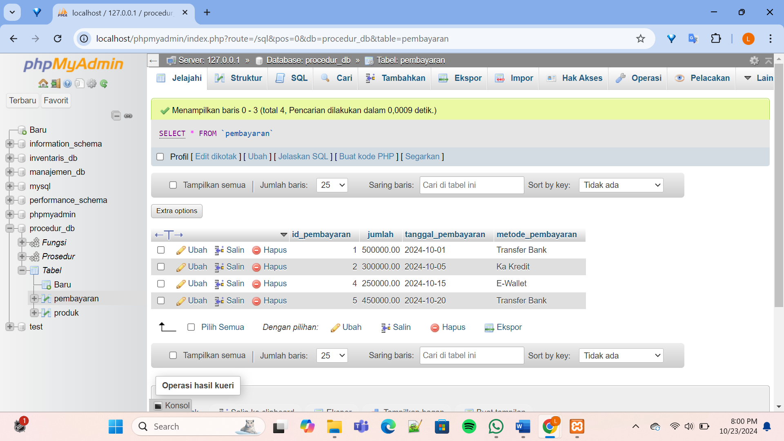

1. Kembali ke savepoint
2. Update data iuran salah satu kartu
3. Akhiri transaction dengan commit

* Query : COMMIT;
* Hasil :

